

**St. Mary's C. of E. Primary School**

**Barn Street, Stoke Newington,**

**LONDON N16 0JT**

**Phone: 020 8800 2645 Fax: 020 8802 1687**

**E-mail: admin-office@st-marys.hackney.sch.uk**

**Headteacher: Jane O’Brien**

**‘Through God’s love, we strive to be the best we can be.’**

**SPOT THE TRAINERS**

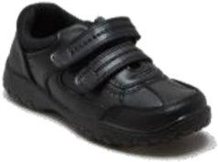a) b) c)

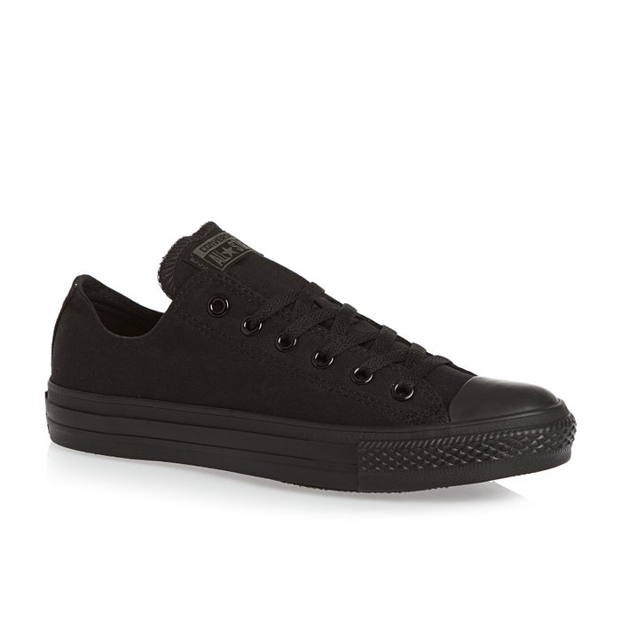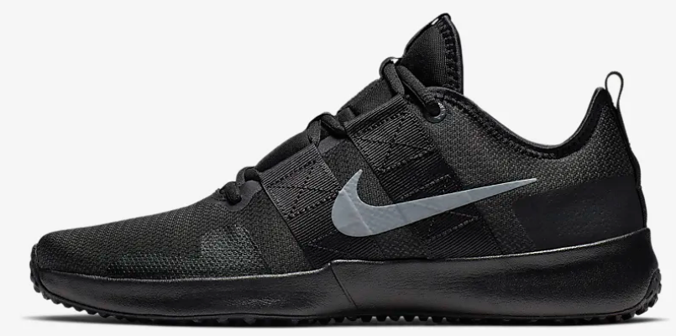

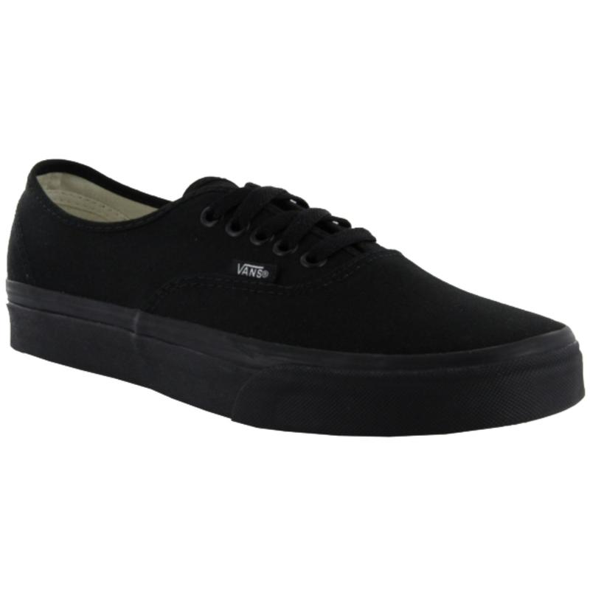d) e) f)

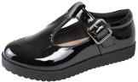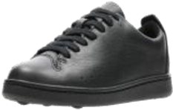

Can you spot the three pairs of trainers/casual shoes that are inappropriate for St Mary’s school uniform?

We have noticed a number of black trainers creeping across Key Stage 2 this year. When purchasing new school shoes for September please remember that if you are about to purchase shoes with stripes, swooshes, flicks, ticks, coloured soles or obvious brand labels;– then it is a trainer and not part of school uniform.

Answers: The trainers are: b), c), and f).