

**St. Mary's C. of E. Primary School**

**Barn Street, Stoke Newington,**

**LONDON N16 0JT**

**Phone: 020 8800 2645**

**E-mail: admin-office@st-marys.hackney.sch.uk**

**Headteacher: Jane O’Brien**

***“St Mary’s…. feeding the mind, body and spirit so we can be the best we can be.”***

Tuesday 5th November 2019

Dear Parents and Carers

On **Friday 15th November** we would like all children in the EYFS (Nursery and Reception) to come to school in a dressing up costume as part of our Topic ‘Let’s Pretend’. The costume can be **anything** at all or something you already own. The aim of the day is for the children to dress up and pretend to be something or someone else.

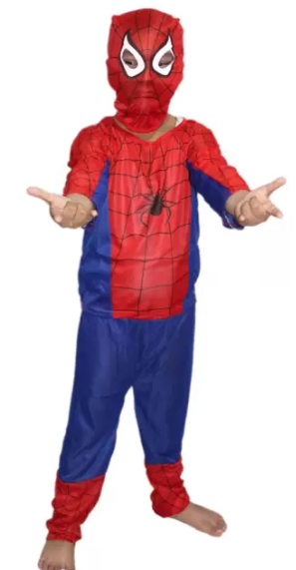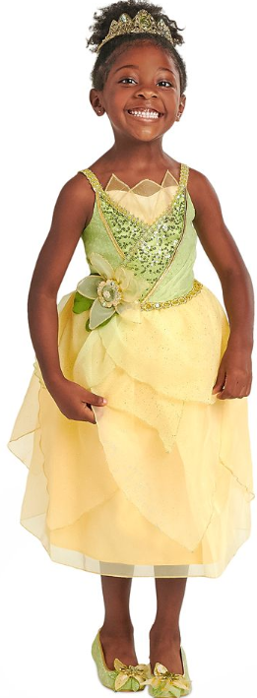

|  |  |
| --- | --- |
| **Some *ideas/suggestions*** | |
| Linked to our specific learning: | Other idea’s you may own or can create/borrow: |
| * Space woman/man * Dinosaur * Fairy Tale Princess/Prince * Alien | * Doctor/Nurse * Superhero * Unicorn/mermaid * Police woman/man |

Face paint is allowed on the day if you wish to do it at home before they come to school, however I ask you not to send any valuable costume props to school that you would not want to be lost or broken.

If you do not own any dress up costumes please send your child into school in non-uniform and we can provide a costume for them to wear from our dress up box.

Kind regards

The EYFS Team